DISSERTATION REPORT ON

YEAR 2011-12

GUIDED BY

Prof. DAS

SUBMITTED BY

Mr.Siddhesh Palav
Mr.Subodh Kokane
Mr.Ajay Mishra
( B.E. MECHANICAL )

DEPARTMENT OF MECHANICAL ENGINEERING
S.S JONDHALE COLLEGE OF ENGINEERING
[ A Leading Technological Institute Maharashtra State]
ASANGAON, DIST-THANE

A PROJECT REPORT

ON

Design and Fabrication of
WORM GEAR OPERATED MANUAL LIFT
(A Project Report submitted in partial Fulfillment of the Requirement for Award of Degree in Mechanical Engineering subject)

Submitted by

Mr.Siddhesh Palav
Mr.Subodh Kokane
Mr.Ajay Mishra
SEM – VIII, B.E. (Mechanical Engineering.)

Guided By
Prof. DAS
Professor of Mechanical Engineering Dept

DEPARTMENT OF MECHANICAL ENGINEERING
S.S JONDHALE COLLEGE OF ENGINEERING
[ A Leading Technological Institute of Maharashtra State]
ASANGAON, DIST-THANE

ACKNOWLEDGEMENT

It is indeed a matter of great pleasure & privilege to be able to present this report on “WORM GEAR OPERATED MANUAL LIFT” under the valuable guidance of Prof. Das (Professor of Mechanical Engineering Department.)
I would like to express my deep sense of gratitude to my guide Prof. Das for his valuable guidance, advice, & constant aspiration to my work.
I would like to express my deep sense of gratitude to our project co-coordinator Prof. Ram Yadav for his valuable guidance, advice, & constant aspiration to my work.
I am also thankful to our HOD & Prof. Amol Dayma Sir and all teachers & Principal of S.S JONDHALE COLLEGE OF ENGINEERING for providing me constant support & facilities.
Lastly I would like to express my sincere gratefulness to all those people who have helped me directly or indirectly for the completion of this work.

----- Thanking

Mr.Siddhesh Palav
Mr.Subodh Kokane
Mr.Ajay Mishra

APPROVAL SHEET

The project repot entitled “WORM GEAR OPERATED MANUAL LIFT” submitted by
Mr.Siddhesh Palav, Mr.Subodh Kokane, Mr.Ajay Mishra is approved for partial fulfillment of requirement for the award of the degree of Bachelor of Engineering in Mechanical Engineering.

Prof. Amol Dayma Prof.Das
Head Department of mechanical Engineering
Department of mechanical Engineering S.S JONDHALE COLLEGE OF ENGINEERING
S.S JONDHALE COLLEGE OF ENGINEERING Asangaon
Asangaon

Principal
S.S JONDHALE COLLEGE OF ENGINEERING
Asangaon

EXAMINERS

1.

2.

INDEX
CHAPTER NO TITLE PAGE NO
ABSTRACT
- INTRODUCTION
2 WIRE ROPE
3 WINCH THEORY OF OPERATION
4 METHODOLOGY
5 DETAIL AND ASSEMBLY DRAWING
6 WORKING PRINCIPLE
7 DESIGN
8 MATERIAL SELECTION
09 FABRICATION
10 COST ESTIMATION
11 CARE AND EXPECTED RESULTS
12 CONCLUSION
13 COST ESTIMATION
14 APPLICATIONS
15 BIBLIOGRAPHY
16 LITERATURE SURVEY

ABBREVIATION
A crane is a mechanical lifting device equipped with hoists, wire ropes and sheaves that can be used both to lift and lower materials and to move them horizontally. Cranes are commonly employed in the construction industry and in manufacturing heavy equipment. Construction cranes have telescoping, lattice or articulating booms. Telescoping boom cranes would include the Industrial, Rough Terrain, Truck Mounted, All Terrain and City Cranes. Lattice boom cranes would include the Crawler Mounted, Truck Mounted, Ringer Mounted and Hammerhead and Luffing Boom tower cranes. A relatively simple crane is the mobile crane. A telescopic boom (arm) or steel truss mounts its movable platform. Either pulleys or levers raise the boom. Generally a hook suspends from the boom.
The platform of a mobile crane can either have traditional wheels, wheels designed for railroad tracks, or a caterpillar track, which is useful for navigating unpaved and uneven surfaces. All cranes represent a meeting of simple machines, used for the purpose of reducing workload. However simple they may seem, they are instrumental in many aspects of industry. They can dig, move, create, or destroy, depending on their type. Cranes exemplify that sometimes the oldest ideas are the best ones
Loads are transferred between stations by horizontal and vertical movement of a pallet table on an elevator mechanism carried by a vehicle from which the table is horizontally extended and retracted when aligned with a preselected storage rack.

ABSTRACT
A worm gear operated manual lift is a machine with a boom, primarily designed to raise and lower heavy loads. Worm geared drive is also called as winch drive. There are two basic winch operated material lift types: mobile and stationary. Mobile winch operated material lifts can be mounted on motor vehicles, boats or railroad cars. Stationary winch operated material lifts can be of a tower type or mounted on overhead rails. Most winch operated material lifts today are power driven, though some still operate manually. Their capacity, depending on the type and size, ranges from a few kilograms to hundreds of tones. Worm geared lifters are also used for pile driving, dredging, digging, demolition and personnel work platforms. Generally, a winch operated material lift's capacity is greater when the load is closer to its mast (centre of rotation) and less when the load is further away from its mast.
Here we the group of four peoples are going to manufacture this unit using our work shop machine tools.

CHAPTER-01
INTRODUCTION

Mobile crane
The most basic type of mobile crane consists of a steel truss or telescopic boom mounted on a mobile platform, which may be rail, wheeled (including "truck" carriers) or caterpillar tracks. The boom is hinged at the bottom, and can be raised and lowered by cables. A hook is suspended from the top of the boom by wire rope and sheaves. The wire ropes are operated by whatever prime movers the designers have available, operating through a variety of transmissions

Crane-like machines
The generally-accepted definition of a crane is a machine for lifting and moving heavy objects by means of ropes or cables suspended from a movable arm. As such, a lifting machine that does not use cables, or else provides only vertical and not horizontal movement, cannot strictly be called a 'crane'.
Types of crane-like lifting machine include:
- Block and tackle
- Capstan (nautical)
- Hoist (device)
- Winch (worm geared)
- Windlass
WORM GEARED DRIVE SYSTREM:-
The worm gears are widely used for transmitting power at high velocity ratios between non-intersecting shafts that are generally, but not necessarily, at right angles. It can give velocity ratios as high as 300:1 or more in a single step in a minimum of space, but it has a lower efficiency. The worm gearing is mostly used as a speed reducer, which consists of a worm & worm wheel or gear. The worm (which is the driving member) is usually of a cylindrical form having threads of the same shape as that of an involutes rack. The threads of the worm may be left-handed or right-handed & single or multiple threads. The worm wheel or gear (which is the driven member) is similar to a helical gear with a face curved to conform to the shape of the worm. The worm is generally made of steel while the worm gear is made of bronze or cast iron for light service.
Worm and Worm Gear
Worm set is the name for a meshed worm and worm gear. The worm resembles a toggle thread; and the mating worm gear a helical gear, except that it is made to envelope the worm as seen along the worm's axis. The outstanding feature is that the worm offers a very large gear ratio in a single mesh. However, transmission efficiency is very poor due to a great amount of sliding as the worm tooth engages with its mating worm gear tooth and forces rotation by pushing and sliding. With proper choices of materials and lubrication, wear is contained and noise is low.
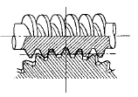
Double Enveloping Worm Gear
This worm set uses a special worm shape in that it partially envelops the worm gear as viewed in the direction of the worm gear axis. Its big advantage over the standard worm is much higher load capacity. However, the worm gear is very complicated to design and produce, and sources for manufacture are few.

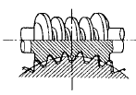

Terms used in worm gearing:
The worm & worm gear is as shown in fig. The following terms, in connection with the worm gearing, are important from the subject point of view:
- Axial pitch : It is also known as linear pitch of a worm. It is the distance measured axially. (i.e. parallel to the axis of worm.) from a point on one thread to the corresponding point on the adjacent thread on the worm, as shown in fig. It may be noted that the axial pitch(pa) of a worm is equal to the circular pitch(pc) of the mating worm gear when the shafts are at right angles.
- Lead: It is the linear distance through which a point on a thread moves ahead in one revolution of the worm. For single start threads, lead is equal to the axial pitch, but for multiple start threads, lead is equal to the product of axial pitch & no. of starts.
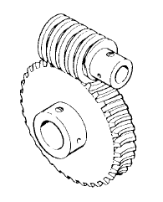The worm gearing is classified as non-inter changeable, because a worm wheel cut with a hob of one diameter will not operate satisfactorily with a worm of different diameter, even if the thread pitch is same.
Generally Winches are rated in line pull, and are usually measured pounds, lbs. or Kg.. The rated line pull is with the first layer of wire rope on the winch drum / single layer.
There are three basic power supply types of winch.
(1.) Low Voltage, = 12v. and 24 volt.
(2.) High Voltage, = 110 volt.
(3.) Hydraulic Only.
Low Voltage and Hydraulic winches are suitable for outdoor use.
The winch sees only the load, that is to say that the line pull is the amount of force the winch needs to produce to move an object. This would be the figure that would be measured on a strength gauge if one was fitted in series with the line (wire rope).
When deciding which model winch to buy, consider the length of wire rope required, as the rated line pull is quoted with the first layer of wire rope on the winch drum. As you winch in the winch becomes less powerful with each layer of wire rope on the winch drum. You should also remember that winch cables never spool onto the winch drum evenly, this results in cable bunching which in turn compounds the problem of layer build up and in turn a loss of pulling power as described below.
As a guide for each layer of wire rope on the drum deduct 10% off the rated line pull. e.g. A winch with a line pull of say 6,000 lbs.. will have a line pull of 5,400lbs.. on the second layer, 4,860 lbs.. on the third layer and 4,374 lbs.. on the fourth layer, etc. So if you need to pull 6,000 lbs.. for any distance, you will need a winch with a greater rated line pull to start with.
You can effectively double the line pull capacity of a winch, by applying what is called a 'double line'. By using a Snatch Block / Pulley Block, you will double the line pull of the winch, but will halve the winching speed, due to the gearing ratio, this is not usually important and is often safer if you are pulling an abnormal load. However, for every pulley you use there is a frictional loss of approximately 10% per pulley.
To effect a true double line, attach the snatch block to the load, wind the wire rope from the winch drum out and around the snatch block pulley, then back and attach the wire rope to a place adjacent to the winch itself. This is a 'Double Line'.
To calculated the size of winch you will require to pull your load you will need to know the weight of the item to be winched : Rolling weight or dead weight. Is it on wheels such as a car? Are you pulling a load not on wheels? What type of surface is it being winched over? Sand? Hard-Core etc.? What gradient is there, if any? What distance do you need to winch over? As you can see, there are many factors that have to be taken into consideration when deciding what size and type of winch to buy. We are able to make the calculations for you, and advise and recommend a winch for your particular needs.
This drawing shows a typical Double Line:
A Double Line as used for self recovery using an anchor point such as a tree.
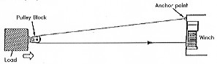
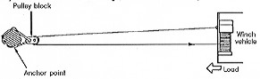
Indirect Double Line Pull
Indirect pulling may be required because of obstacles. The pulley block is attached to the load and the wire rope is attached to an anchor point offset from the direction in which the load is to be moved. Note that this procedure is not recommended unless necessary as the winch pulling power and line speed will decrease as the angle between the wire rope increases.
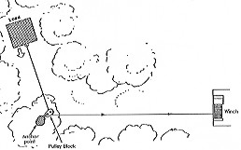
Single Line Pull

Whilst this configuration uses a pulley block it is only a single line pull and the pulling power will be as the winch line pull rating as described above.
Lifting:
Winches are designed as pulling devices and not lifting. Hoists are lifting devices. Winches are often used for lifting due to cost, because £ for lb winches tend to be a lot cheaper than an equivalent hoist.
There are four main criteria to be adopted if using a winch for lifting:
(1.) X safety ratio.
(2.) No Freespool clutch mechanism can be fitted. ( Or it must be removed or disabled )
(3.) A secondary brake must be fitted.
(4.) A safety holding chain or device should be fitted if the load is to be suspended.
A safety ratio, usually a minimum of a 5:1, must be applied to ensure that the winch will lift its rated load safely. Therefore a load of 1,000 lbs. would require a winch with a line pull in excess of 5,000 lbs taking into account that all winches are rated on the first layer of wire rope cable on the drum as explained above means that the likely hood is that your would need a winch in excess of 5,000 lb line pull.
The amount of safety ratio adopted in your calculations should be confirmed by the regulations covering the use you are adopting, you will need to check this carefully.
The winch must not have a freewheel facility. Most winches have a Freespool system fitted as standard, if the winch has such a system then it must be totally disabled or removed.
A secondary brake system is also essential. Most winches rely on the gearing alone to act as the brake. However, some models do have a secondary brake such as a drum brake supporting the geared brake, therefore effectively providing a twin braking system.
Once the load has been raised, if the load is left suspended, then a safety holding device such as a suitably rated chain should be fitted to secure the load. The load must not be left hanging from the winch in free air.
Depending on the lifting configuration, It is good practice and is recommended that when lifting you should use two pulley blocks, one at the top of the lifting tower and one at the base. The winch wire rope should be routed from the winch through the pulley at the base of the tower, up to the upper pulley and then down to the load. Also remember that each pulley / snatch block will reduce the available power by approximately 10% per pulley due to friction losses, these figures must be taken into account when calculating the size / line pull of winch that you will use.
Note, that if a roller fairlead is fitted to the winch and the wire rope is routed direct from the winch to a single pulley block mounted at the top of the tower and then down to the load, the wire rope will be bent around the roller fairlead, this small radius will eventually cause damage to the wire rope and is not recommended.
If you intend to use a winch for lifting purposes, then you must satisfy yourself that it complies with all health and safety laws, and construction and use law. You should also ensure that it satisfies your insurers requirements.
We now have a small winch in our range that has been designed for lifting. A typical use being for small vehicle cranes, see our "C" Crane winch rated at 1,000lbs.

CHAPTER-02
LITERATURE REVIEW
WIRE ROPES
There are different types of wire rope available. The best quality, often referred to as aircraft quality, are of wire core construction, whereas the cheaper types are of nylon core construction. i.e. There is actually a nylon core in the centre of the wire rope, instead of a wire core as in top quality ropes. Then there is the make up of the wire itself, including how many strands of wire there are, this can effect the strength and flexibility of the rope.
Make sure that if a hook is attached, the hook is also capable of handling the load, and that it is correctly stamped with a safe working load. Cheap wire ropes never pay in the long term and can be dangerous. You only get what you pay for.
Some useful tips:

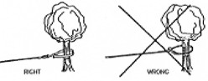
NEVER attach the winch cable back onto itself as shown. Always use a sling with a shackle when using a tree. Make sure you use a soft sling to prevent damaging the tree.
It is good practice to use a heavy blanket or jacket over the wire rope. If a rope failure should occur the weight of the cloth will act as a damper and help prevent the broken rope from whipping. A raised vehicle bonnet will also give some protection should the rope break. Also, the blanket acts as a visual warning to bystanders and is likely to prevent them from walking into or tripping over the wire rope.
You should always make sure that everyone keeps well back and away from any winching activity. However, in the case of a long distance pull you may not see a person who inadvertently walks towards the wire rope, such a cover will help bring the wire rope to their attention. It is recommended that in such circumstances two operators should be in attendance.
Using Cable Clamps on a Wire Rope.
1. Clamps should be spaced 6 rope diameters apart.
2. Ensure that when forming a loop or fitting a thimble that the first and last clamps are not over tightened so as to damage the rope.
3. Both the nuts on each clamp should be tightened equally.
4. Re-tighten the nuts after use and keep checking them on a regular basis.
5. Make sure that you use the correct type and size of cable clamp.
6. You must use a minimum of three clamps as shown below.
7. Make sure that you fit the clamps exactly as shown below. This is VERY IMPORTANT.

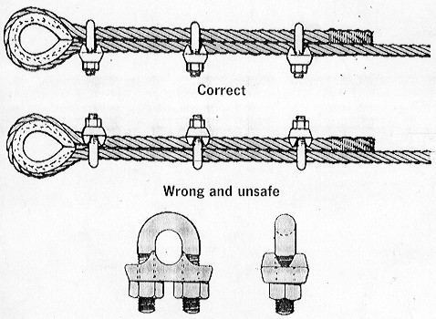
When handling Wire Ropes always wear protective gloves and use a hand saver bar.Check the Wire Rope regularly for any damage or wear.Never use a worn or damaged Wire Rope.Make sure that the Wire Rope is correctly rated for the winch and the load, including any hooks or shackles it is attached to.The Wire Rope should be wound neatly onto the winch drum.
Prevent kinks. Wire Ropes can be DANGEROUS if not handled correctly.
WINCH THEORY OF OPERATION
Winch:-
Winch is a Worm and worm Gear operated wire wounding and un-wounding drum. It is the pair of worm shaft and the worm gear which is made of bright steel. It in engaged condition rotates only when it is rotated with the help of handle. Being removal of the effort it will not get return back due to having square shaped tooth on the worm gear and sometimes the dog lever is installed which stops the reverse motion of the worm gear. this is it’s main advantage of winch used for material handling purpose.. The load bearing capacity of this type of gearing is more. The wire- winding drum installed on the gear shaft is applied with the load through the wire rope.
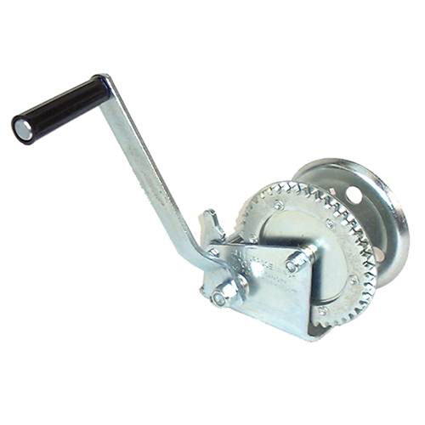
The worm gears are widely used for transmitting power at high velocity ratios between non-intersecting shafts that are generally, but not necessarily, at right angles. It can give velocity ratios as high as 300:1 or more in a single step in a minimum of space, but it has a lower efficiency. The worm gearing is mostly used as a speed reducer, which consists of a worm & worm wheel or gear. The worm (which is the driving member) is usually of a cylindrical form having threads of the same shape as that of an involutes rack. The threads of the worm may be left-handed or right-handed & single or multiple threads. The worm wheel or gear (which is the driven member) is similar to a helical gear with a face curved to conform to the shape of the worm. The worm is generally made of steel while the worm gear is made of bronze or cast iron for light service. The worm gearing is classified as non-inter changeable, because a worm wheel cut with a hob of one diameter will not operate satisfactorily with a worm of different diameter, even if the thread pitch is same.
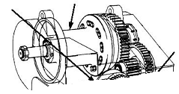

This winch operated material lifting machine is a device in which actual load is overcome by the worm and worm gearing, by actuating the lever; due to its high mechanical ratio and advantage however, lightly you operate the handle lever, the raising action you get on the load platform is consisting. This gives a uniform rising of the load on the platform up to the desired height.
Trolley platform:- It is made from 40x40x5mm section angle in Rectangular shape. It is installed with the trolley wheel at it’s vertical side so as to raise up and lower down the trolley up and down the vertical rail post of the lifting machine.
Fixed bottom platform:-
It is manufactured from the heavy C-channel so as to act as a robust base which support whole weight of the trolley along with the load on the load platform at any vertical destination. At it’s middle portion of the bottom platform the vertical post is installed which acts as the vertical rail for sliding the fork up and down
Frame of the winch operated material lifting machine.:- It is the main vertical post which actually bears the whole load of the crane along with the weight to be raised. It is made of pair of C- channel in size 75x40x5mm section. It is vertically fabricated to raise the height of the load tobe lifted from ground level. It is supported by m.s. angles. At the top of the frame a bracket is fabricated of m.s. strips which holds the main overhead pulley. At the middle of the vertical post another bracket is welded to hold the winch consisting of worm and worm gear

WORKING PRINCIPLE
Whole assembly works on the principle that the mechanical advantage of worm and worm gearing This Worm geared crane machine is a machine in which actual load is overcome by The worm and worm gearing, by actuating the lever; due to its high mechanical ratio and advantage however, lightly you operate the handle lever, the raising action you get on the trolley crane is consisting. This gives a uniform rising
The worm and worm gear operated winch is installed with the wire wrapping drum on the worm gear shaft. This winch is installed on the vertical column posts. The load raising trolley consisting of the four roller wheels which slides up and down in the groove of the vertical channel post along with the load. This trolley is raised up and down by having pull from the rope which is wound or un-wound over the winch drum due to clock wise and anti-clock wise rotation of the worm and worm gearing installed on the winch.
The load to be raised is kept on the fork platform and the handle of the worm shaft is rotated, thus rotates the worm gear. The wire rope drum being installed on the worm gear shagt wounds the wire rope. Due to winding of the wire rope the fork platform along with the load is raised up. The same thing happens while lowering the load, unwounding the wire rope over the drum in anti-clock wise direction.

WINCH
FRAME

METODOLOOGY
ENGINEERING AND ECONOMIC CONSIDERATIONS:
According to George Hageman, the important “Engineering and Economic” factors to be considered in every materials handling installation can be classified as: Factors of plant and operating methods.
Factors depending on materials of parts handled.
Factors relating to the handling equipment.
Money factors.
1. Factors Depending on the Materials or Parts Handled:
Kinds or nature of materials of parts handled.
a) Bulk or units.
b) Large or small.
c) Heavy or light.
d) Shape.
e) Rough or fragile.

- Handled separately or in containers.
- Quantities handled.
- Continuous or intermittent flow.
- Under processing while moving.
- Distances over which transported
3. Factors relating to the Handling Equipment:-
- Kind of kinds suitable for the job.
- Capacity of equipments.
- Hours it will in service daily.
- Size of equipment.
- Space required for operation (For trucks, this factor covers, aisles, passage ways, elevators, platform sizes, etc.)
- Flexibility (According to loads etc.)
- Adoptability to other service.
- Power requirements.
- Ease of operation.
- Speed of operation.
- Durability.
- Relationship to other handling equipment in use of contemplated.
- Auxiliary equipment, which is required or economical to install (loading platforms etc.)
2. Money factors:
- Initial cost of equipment.
- Cost of installation, re-arrangement of and alterations to present
- equipment, to buildings, etc.
- Cost of maintenance, repairs, supplies etc.
- Cost of power.
- Rate of depreciation.
- Rate of obsolesce.
- Probable salvage value when finally described.
- Cost of labour to operate.
- Cost of any necessary auxiliary equipment (such as charging equipment for trucks batteries etc.)
- Taxes and Insurance.
Interest on investment.
License fees (for trucks that may operate on highways).
Rent of space (also garage rent for trucks).
Cost of supervision.
Savings that the equipment will bring about in direct labour cost (number of men released for other work).
Savings in labour burden (supervision etc.)
Increased production brought about.
Savings in fixed charges in equipments displaced.
Unmortized value of equipment displaced.

GUIDING PRINCIPLES OF MATERIALS HANDLING:
Following are some of the important guiding principles of economical handling.
1) Try to minimize handling as much as possible.
2) Make accurate and complete analysis for installations, operation and maintenance cost of proposed devices.
3) Estimate the initial cost if handling equipment.
4) Remove handling work from among the duties of direct labour force, i.e. separate ordinary labour for production work.
5) Transport materials at higher speeds as well as in large quantities at a time.
6) Transport material at constant speed.
7) Run conveys overhead and stack load on top each other or in racks as high as safety permits.
8) Try to avoid back-tracking.
9) Arrange devices for the minimization of transport distances.
10) Avoid remanding of materials.
11) There should not be congested layout.
12) Other things being equal, select the flexible devices.
13) To reduce spares, standardize the equipment used throughout
the industry.
14) Standardize materials and methods.
15) Try to combine movement, storage & processing of material. 16) Provide right equipment and at right time.
i. Operators must be well trained to handle equipment.
ii. It should always be borne in mind that efficient handling is only safe handling.
iii. To reduce damages and injuries, keep passageways lighted and unobstructed.
iv. Unnecessary mixing of materials must be avoided.
v. Use handling devices for scrap materials.
vi. To make arrangement for repairs and maintenance of equip.
vii. An individual may be made responsible for promoting good handling.
viii. Always keep distance over which materials are to move as short as possible.
ix. Always use gravity flow advantages and if it is not possible then select mechanical handling devices.
x. Reduce terminal time of power units.
Transporting Devices:
These are used for transporting the material in horizontal direction. These are:
Wheel borrows.
Hand & power trucks.
Industrial narrow railways.
Tractors & trailers.
Pipe lines
Pumps.
Aerial tram ways.
Devices, which lift & transport:
These are used for lifting, transporting & lowering the materials. These are:
- Chutes
- Hoists with trolleys running on over head rails.
- Fork lift truck
- Crane trucks
- Different types of conveyors
- Spiral chutes
- Spiral rollers
- Cranes.
The winch is having worm gear as it’s main heart object. Hence it becomes necessary to have research study on composition of winch.

TYPES OF WORMS:
The following are the two types of worms.
- Cylindrical or straight worms, &
- Cone or double enveloping worm.
The cylindrical or straight worm, as shown in Fig. (a), is most commonly used. The shape of the thread is involute - helicoids of pressure angle 4.5 degrees for single & double threaded worm & 20 degrees for triple & quadruple threaded worms. The worm threads are cut by a straight sided milling cutter having its diameter not less than the outside of worm or greater than 1.25 times the outside diameter. The cone or double enveloping worm, as shown in fig.(b), is used to some extend, but it requires extremely accurate alignment.
TYPES OF WORM GEARS: The following three are the types of worm gears are important from the subject point of view:
- Straight face worm gear
- Hobbled straight face worm gear
- Concave face worm gear
The straight face worm gear is like a helical gear in which the straight teeth are cut with a form cutter. Since it has only point contract with the worm thread, therefore it is used for light service. The hobbled straight worm gear is also used for light service but it’s teeth are cut with a hob, after which the outer surface is turned.
The concave face worm gear is the accepted standard form & is used for all heavy service & general industrial uses. The teeth of this gear are cut with a hob of the same pitch diameter as the meting worm to increase the contract area.
These are two types of winch.
- single purchase crab winch:
This machine is used to lift the heavy loads. It consists of a load axle ‘A’ on which a Bigger wheel ‘B’ known as spur is mounted. Spur wheel ‘B’ gears with another small toothed wheel ‘C’ known as pinion. The effort ‘P’ is applied at the end of a handle winch is attached on the same axle as that of pinion C. The string is wound on the load axle ‘A’ to which a heavy load ‘W’ is attached.
Let L=length of the handle.
D=diameter of the load axle (A).
N1=no.of teeth on the spur wheel (B)
N2=no.of teeth on the pinion wheel (C)
W=load lifted.
P=effort required to lift the load.
Now for one revolution of the handle, The distance moved by the
effort = 2*pi*I
The pinion wheel ‘C’ also makes one revolution ;& the spur wheel ‘B’ will move through the N2/N1 revolutions.
The load drum will also perform N2/N1 Revolutions. Therefore Distance moved by the load = N2/N1*pi*d
V.R. = distance moved by the effort/Distance moved by the load.
= 2*pi*L / (N2/N1)*pi*d.
V.R. = 2 L / d*(N1/N2)
If instead of the handle of length L, an effort wheel of diameter D is attached on
the axle of the pinion ‘C’, then the distance moved by the effort is pi*D.
V.R. = distance moved by the effort / distance moved by the load.
= pi* D /(N2/N1)*pi*d.
V.R. = D/d*(N1/N2).
- Double purchase crab winch.
The arrangement of a double purchase crab winch is shown in fig. Double purchase crab is nothing but a combination of two single purchase crabs in order to increase it’s velocity ratio. It works on the same principle as that involved in a single purchase crab winch.
Let N1=no.of teeth on the spur wheel on load axle.
N2=no.of teeth on the pinion wheel on intermediate axle.
N3=no.of teeth on the spur wheel on intermediate axle.
N4=no.of teeth on pinion wheel on effort axle.
L= length of the handle.
D= diameter of the load axle.
W=load lifted.
P= effort required to lift the load.
For one revolution of the effort handle the distance moved by the effort is 2*pi*L. The pinion ‘E’ on the effort axle also makes one revolution & the spur ‘D’ on the intermediate axle will move through N4/N3 revolutions. The pinion ‘C’ on the intermediate axle will also move through N4/N3 revolutions.
Therefore, no.of revolutions made by the spur on the load axle =
(N4/N3)*(N2/N1). The load drum will also move through (N4/N3)*(N2/N1)
revolutions.
Therefore distance moved by the load = po*d*[(N4/N3)*(N2/N1)]
V.R. = Distance moved by the effort/Distance moved by the load.
=(2*pi*L)/pi*d*[(N4/N3)*(N2/N1)
V.R. = (2*L/d)*(N1/N2)*(N3/N4)
If instead of the handle of length L, an effort wheel of diameter D is attached on
the axle of the pinion wheel ‘E’, the distance moved by the effort = pi*D.
V.R. = Distance moved by the effort / Distance moved by the load.
=pi*D/pi*d*[N4/N3)*(N2/N1)]
V.R. = (D/d)*(N1/N2)*(N3/N4)

CHAPTER-03
DETAILS , ASSEMBLY DRAWING & DESIGNING
DRAWINGS

50

5 3500
PART NO - 01

NAME – C – CHANNEL FOR FRAME

MATERIAL – MILD STEEL

25 1200

PART NO –02

NAME – ANGLE

MATERIAL – M.S.

5
40
50

5

510
520

540 218

LOAD PLATFORM FRAME

540

40
25
650

BASE PLAT FORM

Φ15

Φ76
20
NAME; PULLEY QUANTITY - 01

PART NO – 03
NAME – WHEEL
QUANTITY - 04

15Ø 28Ø
48 48
358

PART NO – 03
NAME :- ROPE PULLEY SHAFT
QUANTITY :- 01

75ф

22 20ф

35ф

210

WORM & WORM GEAR

PART NO – 04

NAME – DRUM
15Ø
35Ø
08
150

510

90 6000

4
2 835

PART NO – 05
MAIN FRAME -POST

510

6000

510
835 650

ASSEMBLY OF WORM GEARED LIFT

MACHINE DESIGN
I N T R O D U C T I O N
The subject of MACHINE DESIGN deals with the art of designing machine of structure . A machine is a combination of resistance bodies with successfully constrained relative motions which is used for transforming other forms of energy into mechanical energy or transmitting and modifying available design is to create new and better machines or structures and improving the existing ones such that it will convert and control motions either with or without transmitting power. It is the practical application of machinery to the design and construction of machine and structure. In order to design simple component satisfactorily, a sound knowledge of applied science is essential. In addition, strength and properties of materials including some metrological are of prime importance. Knowledge of theory of machine and other branch of applied mechanics is also required in order to know the velocity. Acceleration and inertia force of the various links in motion, mechanics of machinery involve the design.
Consideration in Machine Design
When a machine is to be designed the following points to be considered: -
- Types of load and stresses caused by the load.
- Motion of the parts and kinematic of machine. This deals with the
type of motion i.e. reciprocating . Rotary and oscillatory.
- Selection of material & factors like strength, durability, weight,
- corrosion resistant, weldability, machine ability are considered.
- Form and size of the components.
- Frictional resistances and ease of lubrication.
- Convience and economical in operation.
- Use of standard parts.
- Facilities available for manufacturing.
- Cost of making the machine.
- Number of machine or product are manufactured.

GENERAL PROCEDURE IN MACHINE DESIGN
The general steps to be followed in designing the machine are as followed.
- Preparation of a statement of the problem indicating the purpose of The machine.
- Selection of groups of mechanism for the desire motion.
- Calculation of the force and energy on each machine member.
- Selection of material.
- Determining the size of component drawing and sending for manufacture.
- Preparation of component drawing and sending for manufacture.
- Manufacturing and assembling the machine.
- Testing of the machine and for functioning.

DESIGN OF LIFTING MACHINE
Terms used in worm gearing:
The worm & worm gear is as shown in fig. The following terms, in connection
with the worm gearing, are important from the subject point of view:
- Axial pitch : It is also known as linear pitch of a worm. It is the distance
measured axially. (i.e. parallel to the axis of worm.) from a point on one
thread to the corresponding point on the adjacent thread on the worm, as
shown in fig. It may be noted that the axial pitch(pa) of a worm is equal to
the circular pitch(pc) of the mating worm gear when the shafts are at right
angles.
- Lead: It is the linear distance through which a point on a thread moves ahead in one revolution of the worm. For single start threads, lead is equal to the axial pitch, but for multiple start threads, lead is equal to the product of axial pitch & no. of starts.

1) Design of worm gear:-
Mathematically,
Lead, I=pa*n
Where pa=axial pitch
& n=no.of starts.
- Lead angle: It is the angle between the tangent to the thread helix on the
pitch cylinder & the plane normal to the axis of the worm. It is denoted by λ
- Tooth pressure angle: It is measured in a plane containing the axis of the
worm & is equal to one-half the thread profile angle as shown in fig.
The following table shows the recommended values of lead angle (λ) & tooth pressure angle (Ǿ).
The Torque required overcome friction & load
T = F x d/2 F = load to be raised = 1000 kg = 10,000 N
Therefore, d = max. distance at which the load is to be installed on fork
250 cm

T = 10,000 x 0.25 m
T = 25,00 N-m.
Hence, speed that is transmitted by manual operating from human operating speed of 60 rpm.
It passes through gear box, & reduction in speed having ratio 1:20
Therefore, Speed to shaft = 2 x (Px60) / (2π T)
Here factor ‘2’ is for twice the length of rope {where P = human power
Human hand applied P = 746/2 watts = 373 watts and T is torque =2500Nm
Speed to shaft = 2 x (Px60) / (2π T)
= 2 x (373 x 60 ) / (2 x 3.14 x 2500)
= 2.85 = 3rpm.

Speed of human
The reduction Ratio of gear box = ---------------------
Speed of shaft
60
= -------
3
= 20
therefore, Reduction Ratio = 20:1
But, In market we easily available gear box honing
Reduction Ratio = 20:1
So we select, warm & wheel type reduction gear box reduction ratio 20:1
Given Data: -
Pressur angle =Ø = 20⁰ P = 373 w Nw = 60 rpm
Velocity Ratio V.R. = 20:1 λ = 20.25⁰

- Design of Worm
Let Ln = Normal lead and
λ = Lead angle
We know value of (λ /Ln) will be minimum corresponding to.
cot³ λ = V.R. = 20 OR cot λ = 2.71
λ = 20.25⁰

λ 1 1 V.R.
We know that , -------------- = ------ ----------- + -----------
Ln 2π sin(λ) cos(λ)

20.25⁰ 1 1 20
-------------- = ------ ----------- + --------------
Ln 2π sin 20.25⁰ cos 20.25⁰

1
= ------- (2.88 + 21.32)
2π
Ln = 3.85 mm
And axial lead = Ln / cos λ = 4.10 mm
From table we find that for a velocity ratio of 20, the number of starts or threads
on the worm.

.n = no of start of teeth of worm = Tw (teeth start) = 2
Axial pitch of the thread on the worm.
Pa = 1 / n = 0.5 mm
Since the axial pitch of the threads on the worm is equal to the circular pitch of
teeth on the worm gear.
Pa = Pc = π m, where m is module
m = Pa / π = 0.284 which is too much small
Let us take the std. Value of module, m = 2 mm
Axial pitch of the threads on the worm.
Pa = π m = π x 2 = 6.28mm
Axial lead of the threads on the worm.
Lead =L = Pa x n (no of start)= 6.28 x 2 = 12.56 mm
And normal lead of the threads on the worm.
In = L cos λ = 11.78 mm
Let Dw = pitch circle Dia. Of the worm.
We know that tan = 1 / π Dw
L
Dw = --------------- = 3.588 mm
π tan λ
Since the velocity Ratio is 20 and the worm has double threads therefore no. of
teeth on the worm gear Ta = 20 x 2 = 40
From table we find that the face length of the worm or the length of threaded
portion is calculated by using formula
Lw = Pc ( 4.5 + 0.02 Tw )
= 6.28 ( 4.5 + 0.02 x 2 ) = 28.5 ( Pa = Pc)
This length should be increased by 25 to 30 mm for the feed marks produced by
the vibrating rope drum.
Lw = 55 mm
We know that depth of tooth.
.h = 0.686 Pc = 0.686 x 6.28 = 4.3 mm
And addendum a = 0.318 Pc = 1.99 mm
Outside Dia. of worm
Dow = Dw + 2a = 10.86 + 2 x 1.99 = 14.85mm
.
- DESIGN OF WORM GEAR : -
We know that pitch circle Dia of worm gear
D_{G} = m x T_{G} = 2 x 40 = 80mm
From table we find outside Dia of worm gear
D_{OG} = D_{G} + 1.0135 Pc --- (Empirical formula)
= 80 + 1.0135 x 6.28 = 86.36 mm Ans.
Throat Diameter
D_{T} = D_{G} + 0.0636 Pc = 80 + 0.636 x 6.28 = 84.30 mm
And face width b = 2.38 Pc + 6.5mm (Empirical formula)
= 2.38 x 6.28 + 6.5
= 21.4 mm
- Check for the tangential load
Let Ng = speed of the worm gear in rpm.
We know V.R. of the drive. Nw maximum rpm of worm if motor installed = 1440
Nw Nw 1440
V.R. = -------------- OR NG ------------ = --------- = 72 rpm
Ng V.R. 20

Torque Transmitted.
P x 60 273 x 60
T = ---------- = ------------- = 36.23 N.M
2 π x Ng 2 π x 72
And Tangential load acting on the gear
2 x Torque 2 x 36.23
WT = --------------- = ------------- = 906.6 N
Dg 0.08
We know that pitch line or peripheral velocity of the worm gear
π x DG x NG π x 80 x 72
V = --------------------- = ----------------- = 301.59mm/s = 0.301m/s
- 60
Velocity Factor

- 6
Cv = ----------- = ------- = 0.95
6 + V 6 + 0.301

And tooth form factor for 20⁰ involute teeth,
.y = 0.154 - 0.912 / TG --- (Empirical formula)
= 0.154 - 0.912 / 40
= 0.132
Since the worm gear is generally made of phosphor bronze, therefore the
allowable static stress for phosphor bronze So = 84 N / mm2
We know that the designed tangential load.
WT = ( So x Cv ) b x π x m x y
Where b = width of gear; m = module Cv = service factor = 95%
= ( 84 x 0.95 ) 21.4 x π x 2 x 0.132
= 1416N
Since this is more than the tangential load acting on the gear therefore the design is safe from the stand point of tangential load.

TABLE : RECOMMENDED VALUES OF LEAD ANGLE & PRESSURE ANGLE
Lead Angle  (λ) in  degrees. | 0 - 16 | 16 – 25 | 25 - 35 | 35 – 45
Pressure  Angle (Ǿ) in  degrees. | 14.5 | 20 | 25 | 30

For automotive applications, the pressure angle of 30 degrees is recommended to obtain the high efficiency & to permit overhauling.
Normal Pitch : It is the distance measured along normal to the threads
between two corresponding points on two adjacent threads of the worm.
Mathematically, Normal pitch, pN = pa* cos (λ)
Helix angle : It is the angle between the tangent to the thread helix on
the pitch cylinder & the axis of the worm. It is denoted by (w), in fig. The
worm helix angle is the component of worm lead angle. .i.e.αw + λ = 90
degrees.
It may be noted that the helix angle on the worm is generally quite large & that on worm gear is very small. Thus, it is usual to specify the lead angle (λ) on the worm & helix angle (αG) on worm gear. These two angles are equal for a 90 degree shaft angle.

2) DESIGN OF BOLTS:
Design of bolt:-

Two plates of motor and the foundation are to be fastened together tightly
Stress for C-25 steel ft =420 kg/cm² . Std nominal diameter of bolt is 10mm.
From table in design data book, diameter corresponding to M10 bolt is
8.160mm

Let us check the strength :-
Also initial tension in the bolt
P = 284 d
P = 284 x 10 = 284 x1 = 284 kg Being the four bolts the load is shared as
P= p/4 = 72 kg.
Also, P = Π /4 dc²x ft

72 x 4
ft = -------------- = 136.40 Kg / cm²
3.14 x 0.82²

the calculated ft is less than the maximum ft hence our design is safe.

Checking for safe working of bolt.
bolts are used for fastening the various elements with each othter. E.g. wheels wire rope, holding sheets etc.
Material for bolt = plain carbon steel specification M8
Select the permissible value of shear stress from data book
Fs (permissible) = 100 N/mm²
Consider the shear failure of bolt.

4 x w
Fs = ----------
π x dc

Here,
dc = 0.84 x d = 0.84 x 8 = 6.72 mm.
dm = 2 x 1.21 + core diameter -- Empirical formula
dm = 2 x 1.21 + 6.72
dm = 9.12 mm
Hence we will us M10 size bolts.

Now let us check this diameter for the maximum load on the winch
W = 1000 kg = 10,000 N
This load is to be shared by four no of bolts hence it will be shared among the four bolts
W =10000/4 = 2500 N
4 x 2500
Fs = -----------------
π x (6.72)²

Fs = 70.52 N/mm²

The This Fs is very less than Fs (permissible)
Hence the diameter of bolt is safe.

3) DESIGN OF GEAR SHAFT:-
Let us find the torque transmitted
Here the required load to be raised = 1000 kg
= 1000 X 9.81 = 10,000 N (say)
Force applied on the shaft maximum to rotate the worm .
= 30 kg
= 30 X 9.81 N
So, F = 300 N
reaction R = 250/2
R= 125 mm
Therefore, torque T = F X R
= 300 X 125
= 37500 N-mm
Now let us find the diameter of the shaft,
From design data book for easily available, material M.S.,
ft = 212 N/mm²
And fs = 156 N/mm²
Therefore T = (Π/16) X fs X (D)³
D³ = (16xT)/( Πx fs)
D = ³√(16 x 37500)/(3.14 x 156)
D = ³√1224.9= 10.69 mm = 11 mm
Now let us take factor of safety 2 for increased or impact loading
d = 2x11 =22 mm
Now we will check the shear stress and tensile stress :
fs = 4p/a
= 4p / [(Π/4)d²]
= 4p/( Π x d²)
Fs = 4 x (10000) / [ 3.14(22) ²]
Fs = 40,000 / 1519.76
Fs = 26.32 N/mm²
Thus fs ≤ 156 N/mm²
Hence design is safe.
Also, ft = ( T/ Ip) x r
ft = {[ 37500 / [ (3.14/32) x (22)⁴]] x (22/2)}
ft = 37500 x 7.5
ft = 17.94 N/mm²
4) UPPER PIN SUBJECTED TO COMBINED TWISTING MOMENT & BENDING MOMENT
When the shaft is subjected to combined twisting moment & bending moment, then the shaft must be designed on the basis of the two moments, simultaneously.Various theories have been suggested to account for the elastic
failure of the materials, when they are subjected to various types of combined
stresses. The following two theories are important from design point of view.
- Maximum shear stress theory. It is used for ductile material such as mild
steel.
- Maximum normal stress theory or Rankine’s theory. It is used for brittle
material such as cast iron.
  - Twisting moment (T) may be obtained by using the following
relation:-In S.I. units, power transmitted (in watts) by the shaft.

2NπT P X 60
= ------------- OR T = --------------
60 2πN
Where, T = Twisting moment in N-M &
N = Speed of shaft in r.p.m.
P = Power transmitted in watts.
  - When the shaft subjected to a twisting moment, then the diameter
of the shaft is to be obtained by using the torsion equation.
We know that,
T fs
--- = ---- ………..(i)
J r
Where, T= Twisting moment acting upon the shaft
J = Polar moment of inertia of the shaft about the axis of rotation.
fs= Torsional shear stress &
r = d/2 = where ‘d’ is the diameter of the shaft
  - We know that for round solid shaft, polar moment of inertia,
II
J = ---- X d⁴ …….. (ii)
32
the equation (i) may now be written as,

T fs
----------- = -------
π/32 x d⁴ d/2

T = π/16 X fs X d³ ……(iii)
So d³ = (16xT)/( π x fs)
Here T is different due to small dia of Shaft pin
T = applied force by human x 35 mm length of pin
= 300 x 35 = 10500 N-mm
bending M = applied human load x length of lever
= 300 x 250 = 75000
T = Te = ²√T² + M² = 75731
d = ³√(16 x 75731)/(3.14 x 700)
d = ³√551.3
d = 8.19 mm = 9mm

5) DESIGN OF CHANNELFOR VERTICAL POSTS:-
The horizontal is subjected to the bending stress
Stress is given by => M/I = F/Y
In above equation first we will find the moment of inertia about X and Y axis.
Then take the minimum moment of inertia considering the channel of
std. Size ISLC 100 x 50.
a1 = 100 x 4.4
= 440 mm2
a2 = a3 = 45.6 x 6.6
= 330.96 mm2.
y1= 100/2 = 50 mm.
x1= 4.4 / 2 = 2.2 mm.
x2 = 45.6/2 + 4.4 = 27.2 mm.
y3= 6.6/2 + 93.4 = 96.7 mm.
x3= 45.6 /2/+ 4.4 = 27.2 mm.
Y = [ a1 y1 + a2 y2 + a3 y3 ]
[ a1 + a2 + a3]
Y = [ (440 x 50) + ( 300.96 x 3.3) + ( 300.96 x 96)

1041.92
Y = 52096 / 1041.92
Y = 50 mm.
X = [ a1x1 + a2x2 + a3x3] / (a1+a2+a3)
X = [ 968 16372.22] / 1041.92
X = 16.64 mm.
Moment of inertia about x-axis is found by,
I(xx) = [(b1d1³/12) + a1(y1-y)²] + [(b2d2³/12 ) + a2(y2-y)²]
+[(b3d3³)/12 + a3 (y3-y)²]
= 3666.6 + 2[1092.5+ 656360.65]
= 3666.6 + 1314906 .309
= 1.3 x 10⁶ mm⁴.
Moment of inertia about y-axis is found by,
I(yy) = [(d1b1³/12) + a1(x1-x)²] + 2[(d2b2³/12)+ a2(x2-x)²]
= (709.86 +91745.9) + 2(52150.3 + 33561.1)
= 92455.8 + 2(85711.48)
= 263878.8
= .26 x 10⁶ mm⁴.
By using the formula, M/τ = бs/y
P = 10000N
THIS LOAD WILL BE SHARED ON PAIR OF CHANNELS
P = W/2 = 10000/2 = 5000 N
e = 230
I = 0.26 x 10⁶ mm⁴. y = 50
Therefore, (5000 x 230 x 50) / ( 0.26 x 10⁶)
бs = 221.15 N/mm²
бb = Permissible bending stress = 250 N/mm^{2.}
бs < бb
Hence our design is safe.
6) CHANNEL DESIGN FOR BASE FRAME
LET US CHECK SAFE STRESS INDUCED:-
M_{max} = W x L
= 10000 x 100
= 100000
a₁= 50 x 4 = 200 mm²
a₂= 92 x 4 = 368 mm²
a₃= 50 x 4 = 200 mm²
y₁= 998
y₂= 50
y₃= 2
Y = (a₁ y₁+ a₂ y₂+ a₃ y₃)+( a₁+ a₂ + a₃ )
= ( 200 x98 +368X50+200x2)/ ( 200+386+200)
= 50 mm
h₁ = 48
h₂ = 0
h₃ = 48
Ixx = ( b₁d₁³/12+a₁h₁²) + ( b₂d₂³/12+a₂h₂²) + ( b₃d₃³/12+a₃h₃²)
= ( 50x40³/12+200x48²) +( 4x92³/12+368x0²)+ ( 50x4³/12+200x48²)
= 1181695 mm⁴
FLEXURAL FORMULA:-
M / I =f_{c} / y_{c}
f_{c} = (M / I)x y_{c}
= 5500/1181695.98 x 50
= 0.232 N/mm²
f_{c} = (M / I)x y_{c}
= 100000/1181695.98 x 50
= 4.232 N/mm²
50
100
2
1
3
4
4
f_{t} =0.232 N/mm²
f_{C} =0.232 N/mm²

Since the stress of M.S. material is greater than the calculated one hence the dimensions are safe.

7) Design of welded joint:-
Checking the strength of the welded joints for safety
The transverse fillet weld welds the horizontal channel and angles, plates.
The maximum load, which the plate can carry for transverse fillet weld, is
P = 0.707 x S x L x ft --- Std empirical formula
L = length of welded joint = 25mm
The load of goods along with the friction is 1000 kg = 10000N
This load will be shared by two joints = W/2 = 5000N
Hence, 10000 = 0.707 x 25 x 130 x ft
Hence let us find the safe value of ‘ft’
10000
Therefore ft = --------------------------
0.707 x 25 x 130
ft = 4.35 N/mm²
Since the calculated value of the tensile load is very smaller than
The permissible value as ft=56 N/mm² for material at welded joint.. Hence
welded joint is safe.

8) Design of lever:-
t = thickness of arm in cm. Fb = 200 N/mm²
B = width of arm in cm = 3 x t
Bending moment at 15 cm from center of shaft,
W = maximum force applied by human = 30 kg = 300 N
M = W x L
M = 300 x 250 =75000 Nmm
And section modulus = Z = 1/6 t B²
Z = 1/6 x t x (3t)²
Z = 1/6 x 9 t³
Z = 1.5 t³ cm³.

Now using the relation,
Fb = M / Z
200 = 75000/ (1.5 t³)
t³ = 75000 / (200 x 1.5)
t = 6.29 mm.
B = 6.29 x 3 = 18.89 mm

9) design of wire rope
weight of material to be raised by wire rope = 1000 kg
hence total W = 10000 N
Winch has drum diameter = 100mm
Let us adopt 6 x19 flexible ropes having dia 8,18,12,14,16,18,20,22,24,25,29,32,35,38,41,44,48,51,54 mm –from design data book
rope having ultimate strength = 510 N
The maximum rope diameter d based upon the maximum sheave diameter from data book will be
= drum dia/ rope dia = 100/10 = 10mm
Hence we will adopt 10 mm dia
For rope material E =84 x 10⁴
The diameter of wire = 0.63 d = 0.63mm
Bending load in the rope = E X (0.63d²) x 0.38 / drum dia x 10⁴
= 84 x 10⁹ x 0.63 x10² x 0.38 /100 x 10⁴
= 20,109 N
= 2000 kg
Thus the load lifting capacity of our rope is 2000Kg which twice safe hence our design is safe.
  - C-Channel for platform for holding Load
Selecting ISLC 75 x 40
Moment of inertia at X-axis, Ixx = 11.5 cm⁴
Vertical distance between base of channel and X-axis, y = 1.35 cm.
Checking the stresses induced in the tie,
Tensile stress due to bending, fbt
M / I = fbt / y
Thus, 70108 / 11.5 = fbt / 1.35
Thus, fbt = 8.23 KN/cm²
Compressive stress due to bending, fbc
M / I = fbc / (4 – y)
Thus, 70108 / 11.5 = fbc / (4 - 1.35)
Thus, fbc = 16.15 KN/cm².
As the bending stresses induced are below the permissible stresses 16.5 KN/cm², hence the assumed section is safe.
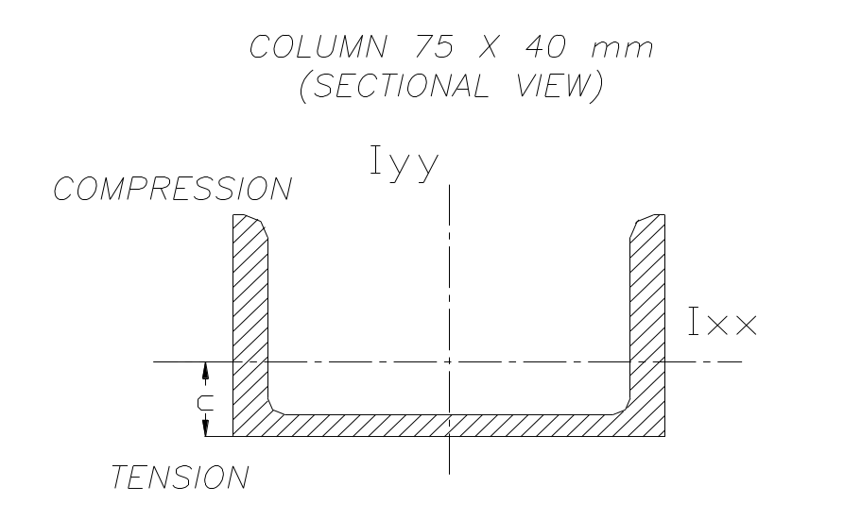
Design of the welded joint of the column to the base plate
The chances of the tensile failure of the weld due to the vertical force at B, is very less then considering the shear failure of the weld due to bending caused by the horizontal force at B. Hence while designing we consider the bending shear failure of the weld.
Maximum horizontal force acting at B, Fhb = 613.86 N.
Load acting at distance from weld, e = 1000 mm.
Size of the weld = s
Throat thickness = t = 0.707 s
Maximum bending shear stress taken for the bare electrode = 20 N/mm²

Throat area of the weld, A1 = (0.707s X 100) + (0.707s X 87.2) +
(1.414s X 50) + (1.414s X 46)
A1 = 268.1 mm²
Direct shear stress, fs = 613 / 268.1s
= 2.28 / s
Bending moment, M = Fhb X e
= 613.86 X 1000
= 613.86 x 10³ N.mm

Finding the section modulus of the weld, Z
- Finding the section modulus of the weld external to the column, Z1
Z1 = t [(t X b) + (b² / 6)]
= 0.707s [(50 X 100) + (100² / 6)]
= 4.7 x 10³ x s mm³
2) Finding the section modulus of the weld internal to the column, Z2
Z2 = t [(t X b) + (b² / 6)]
= 0.707s [(46 X 87.2) + (87.2² / 6)]
= 3.09 x 10³ x s mm³

Total section modulus ,Z = Z1 +Z2
= 7.79 X 10³ X s mm³
Bending stress, fb = M / Z
= 78.69 / s N/mm²
Maximum bending shear stress (fs max.)
fs max = 0.5 √ [fb² + (4 X fs²)]
20 = 0.5 √ [(78.69 / s) ² + 4 (2.28 / s) ²]
Thus, s = 2 mm.

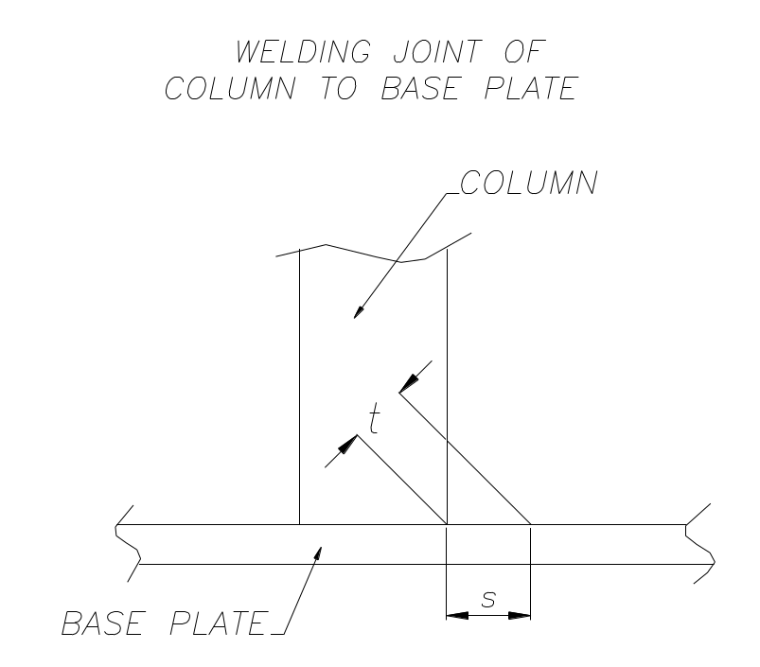

CHAPTER-4
MANUFACTURING PROCESS

SELECTION OF MATERIAL
To prepare any machine part, the type of material should be properly selected, considering design, safety and following points:-
The selection of material for engineering application is given by the following factors:-
- Availability of materials.
- Suitability of the material for the required components.
- Suitability of the material for the desired working conditions.
- Cost of the materials.
- In addition to the above factors the other properties to be conside
red while selecting the material are as follows :-

Physical properties:-

These properties are colour, shape, density, thermal conductivity, electrical conductivity, melting point etc.

Mechanical properties:-
The properties are associated with the ability of the material to resist the
mechanical forces and load. The various properties are:-
i) Strength:- It is the property of material due to which it can resist the
external forces without breaking or yielding.
ii) Stiffness :- It is the ability of material to withstand the
deformation under stress.
- Ductility:- It is the property of material due to which it can be drawn
into wires under a tensile load.
- Malleability:- It is the property of material which enables it to be
rolled in to sheets.
- Brittleness:- It is the property of material due to which it breaks into
pieces with little deformation.
- Hardness :- It is the property of material to resist wear, deformation
and the ability to cut another material.
- Resilence :- It is the ability of the material to store energy and resist
the shock and impact loads.
- Creep :- It is the slow and permanent deformation induced in a
part subjected to a constant stress at high temperature.
We have selected the material considering the above factors and
also as per the availability of the material. The materials which covers
most of the above properties are :-
- MILD STEEL :-
Composition :- Carbon→ 0.20 % - 0.30%
Manganese→ 0.30% - o.60%
Different part are made of mild steel are as follows:
- Channel
- Guide for spindle and threaded bolt.
- Handlever
- Rack shaft
- Supporting plate
Reason for using mild steel:
- Is readily available in the market.
- It is economical in use.
- It is available in standard size and dimensions.
- It has good mechanical properties i.e. easily machinable.
- It has moderate factor of safety.
- It has high tensile strength and low coefficient of thermal expansion.
Properties :- Tensile strength 44.54 kgf/mm²
Yield stress 28 kgf/mm²
Hardness 170 BHN
Uses :- General purpose steels for low stressed components.
2) BEARING METALS :-
They may be classified into:
  - Copper base bearing metals.
  - Tin base bearing metals
  - Lead base bearing metals.
  - Cadmium base bearing metals.
Copper has metals are used for application of heavier Pressures.
Tin base, lead base and cadmium base metal are also known as white metal
alloys.
Tin base metals are used for application of high pressure and loan. Lead base
metals are used for light loads and pressure.
Cadmium base metals have more compressive strength as compared to the base metals used for elevated temperature.
The application of cast iron & steel may be specified as follows:
- Steel should be preferred for simple heavily loaded structure which are
to be manufactured in small numbers; this is due to the factor that in lightly
loaded structures the higher mechanical properties of steel cannot be fully
exploited.
- Cast iron should be preferred for complex structures subjected to normal
loading. When these structures are to be made in large numbers.
- Lately, combined welded and cast structures are becoming popular.
They are generally used where a steel structure is economically suitable but
is difficult to manufacture wing to the complexity of some portions; these
complex portions are separately cast & welded to the main structures. An
example is that of cast bearing housings that are welded into the feed box.

SR NO | COMPONENT | MATERIAL | SPECIFICATION
1. | FRAME | M.S. | AS PER DRG
2. | ROLLERS | BRIGHT STEEL
3. | SUPPORT | M.S. ANGLES
4. | ROPE | H.S.S.
5. | NUT, BOLT | M.S.
6. | TROLLEY WHEELS | C.S.
7. | WORM SHAFT | BRIGHT STEEL
8 | WORM GEAR | BRIGHT STEEL
9 | CASING | M.S.
10 | BUSH | GUN METAL
11 | BEARING | CHROMIUM STEEL
12 | PLATES | M.S.
13 | HANDLE LEVER | M.S.

FABRICATION
METHOD STUDY:
Method of the study is the systematic recording & critical Examination of
existing & proposed ways of doing work, as a means of developing & applying
easier & more effective methods & reducing costs.
OBJECTIVES;
- The improvements of processes & procedures.
- The improvements of factory, shop & work place. Layout & design of
plat & equipment.
- Economy in human effort.
- Improvements in the use of materials, machines & manpower.
- The development of better physical working environment.
RECORDING TECHNIQUES:
The next step in basic procedure after selecting the work to be studies is to
record all the facts relating to existing methods.
PURPOSE OF RECORDING:
- To enable the process to be clearly understood.
- To present the existing facts for analogs.
FLOW PROCESS CHARTS:
Flow process chart is defined as a graphic representation of all storages,
occurring during a process or procedure which includes information considered
Necessary for analysis such as time required quantity & distance moved etc.
TYPES OF FLOW PROCESS CHART:
  - man type : It records what the worker does.
  - material type: It records what happens to the materials.
  - Equipment type: It records how the equipment is used.
Flow process chart gives a complete picture at what is being done & helps the
man to understand the facts & their relationship to one another.

OBJECTIVE OF FLOW PROCESS CHART:
- To visualize the complete sequence of events occurring in process.
- To study the events in a systematic way for the complete analysis of the
manufacture of the component part for the following purposes.
  - To improve the layout
  - To improve material handling
  - To reduce delays.
  - To diminutive, combine or re-arrange the events in a systematic
way.
- To submit the proposals to managements in a form which can be easily
understood.
- To guide supervisors & operators regarding detailed operating
instructions.
According to the nature of job being studies & purpose for the record is
required.
    - CHARTS : Outline process chart
Flow process chart : man type
Flow process chart : material type
Flow process chart : equipment type
B)CHARTS : using time scale
      - multiple activity chart
      - simo chart
      - P.M.T.S. chart
C) DIAGRAMS INDICATING MOVEMENTS & MODELS:
    - Flow diagrams
    - String diagrams
    - Cycle graph
    - Chromo cycle graph
    - Travel chart
- To compare between two or more alternative methods.
- To select operations for a detailed study.
PART NO – 01 QUANTITY – 01
NAME – frame of MECHANICAL winch operated manual lift
No. | Operation  Sequence | Machine tool used | Tool used | Accessories used | Measuring Instr. | Time  min
1  2  3  4  5  6  7  8 | Marking of required length of channels.  Cutting of required length of channels  Arranging channels on ground for marking for making the proper base for frame  Welding of the base of the frame to get a rigid construction.  Grinding of the faces nd ends of the channel to be faced vertically to get a perfect normal surface.  Arranging of the channels on the frame vertically  Welding of the vertical channels to the base.  Cutting of channel pieces for joining wheels to the frame. | Power  Saw  Welding transfrmer  Portable grinder  --  welding transfrmer  power hack saw | Hack saw blades | M/c vice to hold  --  --  --  --  m/c vice | Steel rule  --  measuring tape  -  --  Measuring tape  --  steel rule | 15  50  10  15  20  5  15  50

PART NO – 01 QUANTITY - 01
NAME – FRAME OF MECHANICAL WINCH OPERATED MATERIAL LIFT

SR NO | OPERATION SEQUENCE | M/C TOOL USED | TOOL USED | ACCESS  ORIES | MEAS.  INSTRS. | TIME
9  10  11  12 | Marking of position of oles to accommodate bolts of wheel  Drilling of holes on the marking made  Fastening of the wheels to the drilled channel piece.  Welding of the wheels & channel pieces to the base of the frame. | --  drilling machine  --  welding transformer | Centre punch  Centre drills  Spanner set  Welding electrode | Bench vice  Drill vice  Bench vice  -- | Steel rule  --  --  -- | 10 min.  20  min  10  min  30  min

PART NO – 02 QUANTITY - 02
PART NAME – SHAFTS FOR SUPPORTING ROLLERS

SN | OPERATION SEQUENCE | M/C TOOL | TOOL USED | ACCESS. | MEAS.  INST. | TIME
1  2.  3.  4.  5. | Selection of M.S. Round bars of required sizes & marking on them for required length.  Cutting of the shaft material of required size.  Facing & straight turning of shaft up to required dimension.  Center drilling on both ends of shaft.  Step turning at both ends of shaft for accommodating rollers. | -  Power hacksaw  Center lathe  Center lathe  Center  Lathe | -  Hacksaw blade  HSS tools  Center  Drill  HSS tools | -  M/c.vice  M/c.vice & chuck  M/c.vice chuck  M/c.vice & chuck | Steel Rule  -  Vernier calliper  -  Vernier calliper | 5 minute  20 Min.  30 Min.  10 Min.  20 Min.

PART NO.:3 QUANTITY : 1
NAME : SHAFT FOR SUPPORTING PULLEY.

Op.No. | OPERATION  SEQUENCE | MACHINE  TOOL  USED | TOOL  USE | ACCE  SSORIES  USED | MEASURING  INSTR. | TIME
1.  2.  3. | Selection of M.S. round bar & marking of reqd.length  Cutting of the shaft material of reqd.size.  Facing & turning of the shaft upto the reqd.dimn. | -  Power hacksaw  Center lathe | -  Hacksaw  Blade  HSS tools. | -  M/c.vice for holding material.  Chuck or M/c.vice | Measuring tape or steel rule.  Vernier calliper  Vernier calliper | 5 Min.  10 Min.  20 Min.

PART NO –05
QUANTITY—01 PAIR
NAME –WORM & WORM GEAR

SR. NO. | OPERATION | M/C.  TOOL  USED | TOOL  USED | ACCES-SORIES  USED | MEASURING  INSTRUMENT | TIME
01  02  03  04  05  06  07 | Cut the m.s. rod 0f 20 dia. For 400mm length  Cut the m.s.rod of 100 mm dia for 20mm width  Face and turn both the rods to make it true.  Install it on the indexing head of milling m/c  Cut the tooth  Cut the slot for key way  Heat it and quench it to make it hard. | Power saw  --do—  univ.  lathe  Univ. milling m/c  --do—  slotting m/c  coal furnace | H.S. blade  --do—  single pt. Tool  spanner set  form cutter  slotting tool  tongue | Steel rule  --do—

PART NO.5 QUANTITY : 1
NAME : PULLEY

OP.No. | OPERATION  SEQUENCE | MACHINE  TOOL USED | TOOL  USE | ACCE  SSORIES USED | MEASURING  INSTRUMENT | TIME
1.  2.  3.  4.  5.  6.  7. | Selection of reqd. material & marking of required length.  Cutting of the reqd. length of work piece.  Straight turning & facing upto the required dimensions.  Center drilling at one end of faced side.  Drilling throughout the work piece  Boaring of drilled hole to suit the outer dia of Part no.,3.  Grooving on the outer dia of turned material for accommodating the rope. | -  Power hacksaw  Center lathe  Center lathe  Center lathe  Center lathe  Center lathe | -  Hacksaw blade  HSS tool  Center drill  Drill of reqd.size  Boring Bar & tools  HSS tools | -  M/c.vice  M/c.vice & chuck  M/c.vice & chuck  M/c.vice & chuck  M/c.vice & chuck  M/c.vice & chuck | Steel rule  -  Vernier calliper  -  -  Vernier calliper  Vernier calliper | 5 Min.  10 Min.  20 Min.  5 Min.  5 Min.  10 Min.  20 Min.

CHAPTER-5
EXPERIMENTATION
COST ESTIMATION OF CRANE
COST ESTIMATION:-
The importance of cause estimation is well known as any manufacturing concern. Estimates are basis on which any factory fills up leaders & start production work after accepting that the manufacture of any particular component will be a profitable business. Both were estimating & center estimating are dangerous to concern. Over estimation leads to heavy financial losses. Hence greater care has to be taken while preparing estimate.
An estimate has defined as a guess for calculating of cost which are likely to be incurred in the production of component. Before it is actual manufacture base of all known facts. In addition it also determine the quality of materials, tools used & type of labour etc.
PURPOSE OF COST ESTIMATION:
The following are the minimum functions of cost estimation.
- It provides cost of manufacture of product.
- It controls the cost of product or component by analysing the constituents of cost.
- It compares the cost estimated of various methods or processes of doing
the job.
- It gives good decision in manufacture & purchase of raw material.
- In the absence of established data it provides the basis of price setting.
NEED OF COST ESTIMATION:
- The selling price of product that ensures reasonable profit to the
company is economical to be manufactured in the company.
- Decides whether the part or assembly is to be purchased.
- Initial means of cost reduction.
- Determine the most economical process or material in manufactured product.
The costs accounted in this project are material cost, machining cost & cost of
standard parts & cost of indirect expenses.

COST ESTIMATION OF CRANE:
SR  NO. | NAME OF THE PART | QUANTITY/  WEIGHT | RATE | TOTAL COST  RS.
1. | M.S. channels | 50 kg | 42 Rs/kg | 2100
2. | Worm gear | 1 | 730 Rs. | 730
3 | Worm shaft | 1 | 400 | 400
4 | Wire locks | 2 | 100 | 200
5 | Wire Rope | 5 m. | 50 Rs/m. | 250
6 | Metal Hook | 1 | 35 Rs. | 35
7 | Both side movable wheels. | 4 | 160 Rs/wheel | 640
8 | Upper pulley | 1 | 280 | 280
9 | M.S. Angles | 8 feet | 42 Rs/kg | 450
10 | M.S.Round Bar Dia.30mm | 150cm | 42 Rs/kg | 280
11 | M.S.Round Bar Dia.40mm | 16cm | 42 Rs/kg | 225
12 | Wheel shaft  (M.S. Round Bar) (Dia.70mm.) | 1 | 42 Rs/kg | 175
13 | Caster wheels | 4 | 500 | 2000
14 | m.s. sheet 6mm thick x 300 x 500 | 1 | 500 | 500
15 | m.s.strips 40 x 4 x 600mm length | 2 | 250 | 500
16 | Drum pipe | 1 | 500 | 500
 |  |  | Total | 9269

COST OF material = 9269 Rs.
- Machining cost:-
Here we have to work on the different machines for having different Operations. So the machine is being hired for that much period of time. Considering the depreciation and the electric light bill along with the rent of The work shop or the initial investment, the machining cost is calculated as the cost in Rs./hour.
Sr.No. | Machine | Time  In hours | Rate  In Rs. | Operation | Rupees
1 | Lathe | 4 | 350 | Turning and boring | 1400/-
2 | Milling m/c | 3 | 350 | Teeth, slot and gears | 1050/-
3 | Welding M/C | 3 | 80 | Fixing the linkages | 240/-
4 | Drilling M/C and tapping Die set | 3 | 80 | Making holes and, threads | 240/-
5 | Boring attachment | 1.5 | 100 | Finishing inner dia. | 150/-
6 | Grinding M/C | 2 | 80 | Finishing the comp. | 160/-
7 | Cutting M/C | 2.5 | 80 | Parting off  Objects | 200/-
 | Total |  |  |  | 3440/-
Hence the total machining cost = 3440/- Rs.
( C ) Labour cost :-The labour cost consists of the amount incurred on the wages paid to theOperators. The cost is calculated based on the calculation of the hourly wages paid to the operator. Here the operator is considered as the skilled operator.
Hence the total manufacturing cost = A + B + C
= 9269 + 3440
= 12,709/-

IF LABOUR COST ADDED
The labour cost is calculated as under:-
Sr. no | Operation | Hours | Rate/hours | Amount paid
1 | Turning | 4 | 160 | 640/-
2 | Milling | 3 | 160 | 640/-
3 | Welding | 3 | 150 | 450/-
4 | Drilling & tapping | 3 | 150 | 450/-
5 | Boring | 1.5 | 160 | 240/-
6 | Grinding | 2 | 150 | 300/-
7 | Cutting | 2.5 | 150 | 375/-
8 | Assembly and painting | 3 | 100 | 1300/-
 | Total cost | 22 |  | 4395/-

Hence the total labour cost incurred = 1395/- Rs.
Hence the total manufacturing cost = A + B + C =9269 + 3440 +4395= 17,104/-

CARE AND EXPECTED RESULT
Safe operation of a winch operated material lift is the responsibility of all parties involved. Winch operated material lift manufacturers are responsible for designing and manufacturing winch operated material lifts that are stable and structurally sound. Winch operated material lifts must be rated properly so that there are enough safeguards to prevent accidents caused by overloading and instability. Instruments such as load-limiting devices and angle and boom length indicators aid operators in the safe operation of a winch operated material lift. (Powerline sensory devices have proved to be unreliable.) Every winch operated material lift should have a reliable, efficient, automatic safe- load indicator. In addition, winch operated material lift manufacturers must make accommodations in the design that facilitate safe access for servicing and safe operation. Hazards can be reduced by clear design of control panels, providing a chart at the operator's fingertips that specifies load configurations, handrails, non-glare windows, windows that extend to the cab floor, comfortable seats and both noise and thermal insulation. In some climates, heated and air-conditioned cabs contribute to the worker's comfort and reduce fatigue.Winch operated material lift owners are responsible for keeping their machines in good condition by ensuring regular inspection and proper maintenance and employing competent operators. Winch operated material lift owners must be knowledgeable so that they can recommend the best machine for a particular job. A winch operated material lift assigned to a project should have the capacity to handle the heaviest load it must carry. The winch operated material lift should be fully inspected by a competent person before being assigned to a project, and then daily and periodically (as suggested by the manufacturer), with a maintenance record kept. Ventilation should be provided to remove or dilute engine exhaust from winch operated material lifts working in enclosed areas. Hearing protection, when necessary, should be provided. Site supervisors must plan ahead. With proper planning operating near overhead powerlines can be avoided. When work must be done near high-voltage power lines, clearance requirements should be followed (see table 93.6). When working near powerlines cannot be avoided, the line should either be de-energized or insulated.

Following are the expected observations:-
- The load raised up to 5 FEET height
- For that load rotations of the handles are required may depend on gear ratio.
- Gearing ratio of the worm and worm gear around 1:20
- Weight raising capacity of the machine around 1 ton
- Total weight of the machine around 100 kg
- For 100feet of distance it may convey the load
- With 4 km/hour it may travel using rolling wheels
Experiment outcomes
While operating our creation we have observed the following facts:-
Sr no | Rotations of handle in no of rotations | Height up to which weight can be raised in cm
1 | 5 | 10
2 | 10 | 25
3 | 15 | 40
4 | 20 | 55
5 | 25 | 68
6 | 30 | 79
7 | 35 | 95
8 | 40 | 110
9 | 60 | 130
10 | 80 | 150

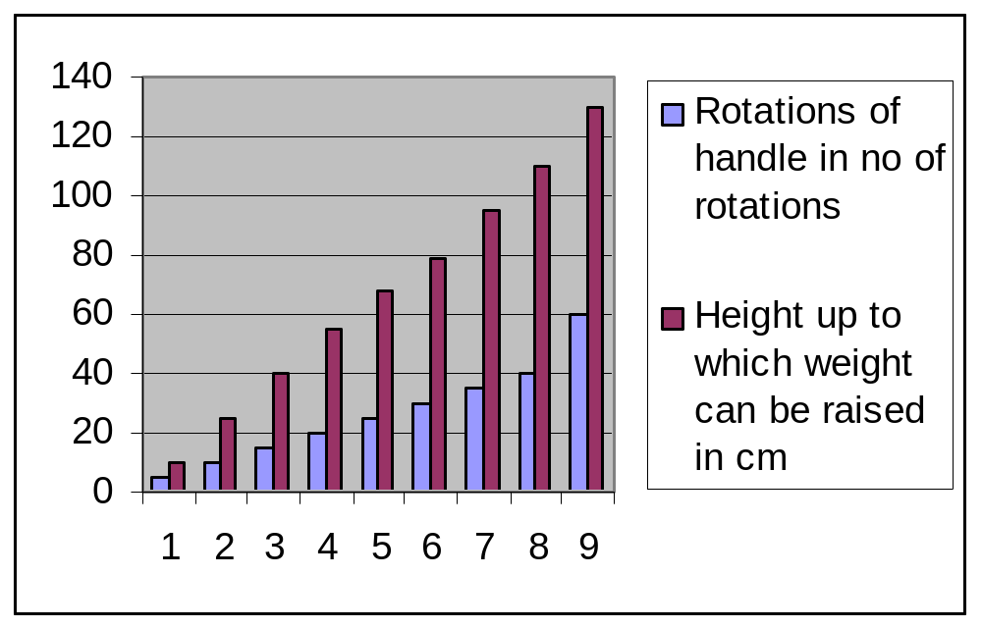

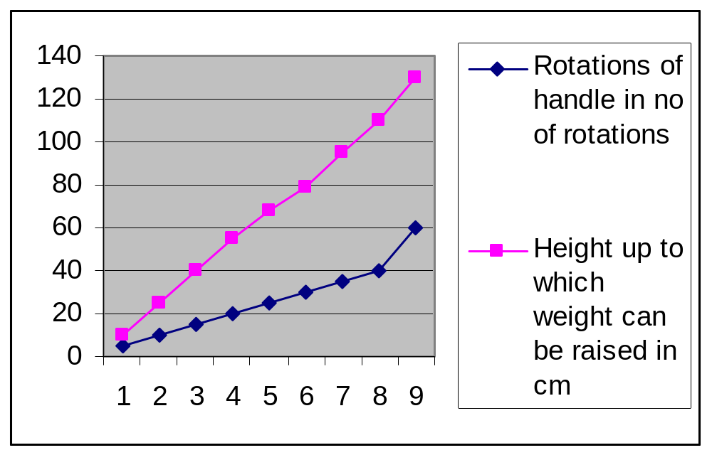
- Let us take few more observations fo no of rotations of winch handle required to raise the different weight on the platform:-

Serial no | Weight to be raised  In kg | In put force required
1 | 20 | 5
2 | 40 | 15
3 | 60 | 20
4 | 80 | 22
5 | 100 | 25
6 | 150 | 30
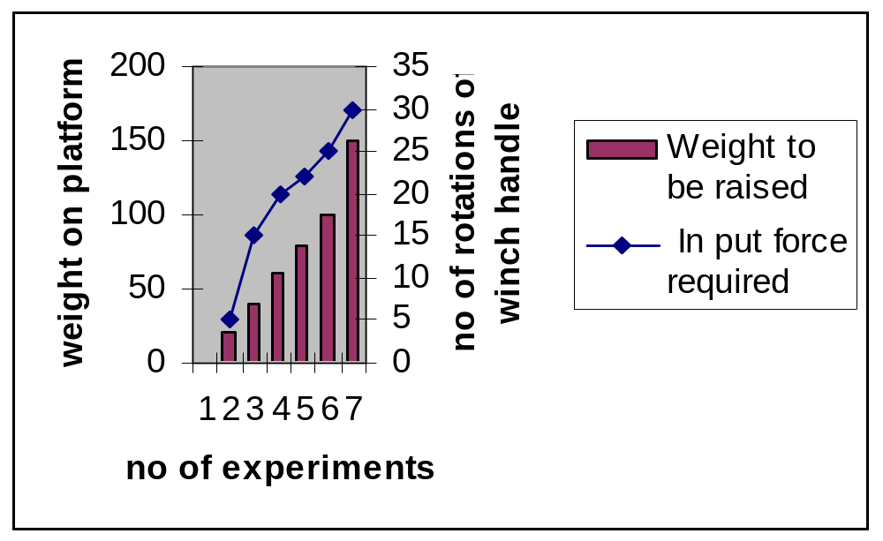

CHAPTER-06
RESULT & CONCLUSION
WE CONCLUDE THE FOLLOWING :-
- The mechanical advantage of worm and worm gearing is much more useful for material handling in vertical plane
- We can handle massive weight with out use of electricity
- Mechanical advantage of mechanism eliminates the massive human effort
- Testing, trial was done on machine, the performance of machine and
efficiency of machine, satisfactory.
- The items manufactured are in proper sequence.
- In production of ‘worm and worm’ gear, adjustment of milling machine
is very difficult and time expensive. We overcome this problem by proper
guidance of ‘Mr. Devatale sir.
- We became familiar with different types of materials and it’s metallurgy.
- We could understand different heat treatment processes.
- We could have market survey of the raw material and finished products.
- We could have Industrial visit of esteemed organization.
This project is very much advantages in developing the knowledge of different
machines and developing the operating skill of different machines in our project
since ‘worm and worm gear’ arrangement is used we come to the arrangement
that how they are designed. We got knowledge about the various materials that
can be used such as OHNS(oil hardened steel), WPS( water proofing steel), EN-
8 etc. and when they are suitable to use.

CHAPTER-07
APPLICATIONS
FOLLOWING ARE THE APPLICATIONS OF OUR CREATION:-
- For down loading engine from the automobile chassis
- For toeing the automobiles which are under rrepair or in break down situation.
- For raising the drums up to the truck body chassis.
- For stacking the heavy materials in the racks in the company store.
- For material handling purpose.

CHAPTER- 08
BIBLIGRAPHY
This project report has been completed with the help of the following reference
books.
Sr. no. Name Authors
1. Machine design R.S.Khurmi & J.K. Gupta
2. Advanced M.S. Mahajan &A.G.Matani
Manufacturing
Process
3. Applied Sunil S.Deo
Mechanics
4. Production M.S. Mahajan
Technology

Bibliography
- Bhandari, V B (2007), Design of Machine Elements, Tata McGraw-Hill, ISBN 9780070611412, http://books.google.com/books?id=f5Eit2FZe_cC.
- Martin, Joe (2004), Tabletop Machining: A Basic Approach to Making Small Parts on Miniature Machine Tools, Vista, California, USA: Sherline, Inc., ISBN 978-0-9665433-0-8. Originally published in 1998; content updated with each print run, similar to a "revised edition". Currently in the fourth print run.
Shigley, Joseph E.; Mischke, Charles R.; Budynas, Richard Gordon (2003), Mechanical Engineering Design (7th ed.), McGraw Hill, ISBN 9780072520361, http://books.google.com/books?id=j8xscqTxWUgC

